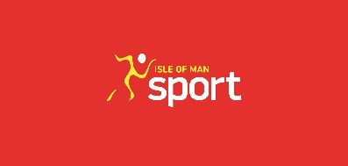
Support for Sport Claim

Association name: |  | Period: | April 1st 2021 – 31st March 2022

Date | Reference | Description | No. of Individuals Claiming (if applicable) | Total Costs | Total amount to be Claimed
*Please insert rows as required for multiple claims

Amount to be claimed:

Before submitting this claim, the named Governing Body of Sport has:
- Read the guidelines for claiming and adhered to them.
- Included all relevant invoices / receipts / proof of expenditure with this claim.
- Checked that all information and details supplied is correct to the best of their knowledge.
This form must be completed and forwarded to the Sports Liaison Officer, IOM Sport, National Sports Centre, Groves Road, Douglas or sent by e-mail to: louise.corkill2@gov.im

